**PPD42NS**

**Arduino Code**

int pin = 8;

unsigned long duration;

unsigned long starttime;

unsigned long sampletime_ms = 30000;//sampe 30s ;

unsigned long lowpulseoccupancy = 0;

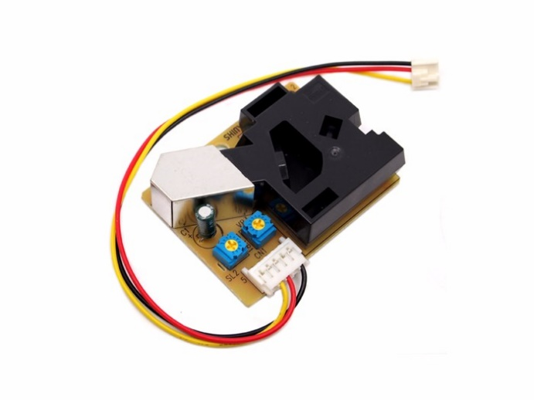float ratio = 0;

float concentration = 0;

void setup()

{

Serial.begin(9600);

pinMode(pin,INPUT);

starttime = millis();//get the current time;

}

void loop()

{

duration = pulseIn(pin, LOW);

lowpulseoccupancy = lowpulseoccupancy+duration;

if ((millis()-starttime) > sampletime_ms)//if the sampel time == 30s

{

ratio = lowpulseoccupancy/(sampletime_ms*10.0); // Integer percentage 0=>100

concentration = 1.1*pow(ratio,3)-3.8*pow(ratio,2)+520*ratio+0.62;   
// using spec sheet curve

Serial.print(lowpulseoccupancy);

Serial.print(",");

Serial.print(ratio);

Serial.print(",");

Serial.println(concentration);

lowpulseoccupancy = 0;

starttime = millis();

}

}

-> low 값인 시간을 통해 수치를 확인

**Reference**

<http://wiki.seeedstudio.com/Grove-Dust_Sensor/>

<http://www.osbss.com/tutorials/particle-sensor/>